Subset sum using recursion (here we have 2 cases,either we do it or don’t)!

<https://www.cnblogs.com/grandyang/>

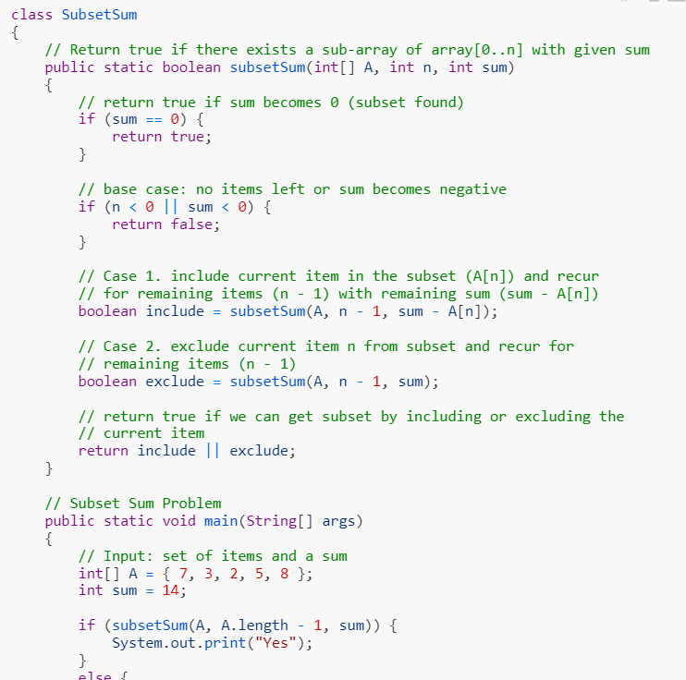

[[LeetCode] Best Time to Buy and Sell Stock with Cooldown](https://www.cnblogs.com/grandyang/p/4997417.html)

Say you have an array for which the *i*th element is the price of a given stock on day *i*.

Design an algorithm to find the maximum profit. You may complete as many transactions as you like (ie, buy one and sell one share of the stock multiple times) with the following restrictions:

* You may not engage in multiple transactions at the same time (ie, you must sell the stock before you buy again).
* After you sell your stock, you cannot buy stock on next day. (ie, cooldown 1 day)

**Example:**

prices = [1, 2, 3, 0, 2]

maxProfit = 3

transactions = [buy, sell, cooldown, buy, sell]

This question is the issue of buying and selling stocks, preceded by four similar topics [Best Time to Buy and Sell Stock trading the best time to stock](http://www.cnblogs.com/grandyang/p/4280131.html) , [Best Time of two of the best times to Buy and Sell Stock II to buy stocks](http://www.cnblogs.com/grandyang/p/4280803.html) , [Best Time to Buy and Sell Stock III is the third best time to buy stocks](http://www.cnblogs.com/grandyang/p/4281975.html) and [Best Time to Buy and Sell Stock IV is the fourth best time to buy and sell stocks](http://www.cnblogs.com/grandyang/p/4295761.html) . The difference between this question and the above lies in the addition of a freeze period called Cooldown, that is, if the stock is sold one day, the stock cannot be bought the next day, and there is a one day freeze period. I don't know much about this problem, so I saw the solution of the online god, click [here](https://leetcode.com/discuss/71354/share-my-thinking-process) . According to his solution, this problem needs to maintain three one-dimensional arrays buy, sell, and rest. among them:

buy [i] indicates that the last operation before day i is to buy, and the maximum profit at this time.

sell [i] indicates that the last operation before the i day is sell, and the maximum profit at this time.

rest [i] indicates that the last operation before the i day is the freezing period, and the maximum benefit at this time.

We write the recursion as:

buy[i] = max(rest[i-1] - price, buy[i-1])

sell[i] = max(buy[i-1] + price, sell[i-1])

rest[i] = max(sell[i-1], buy[i-1], rest[i-1])

The above recursive formula is a good indication that there is a freezing period before buying, and that the previous stock must be sold before buying. A little trick is how to ensure that the situation of [buy, rest, buy] does not occur, this is because buy [i] <= rest [i], that is, rest [i] = max (sell [i-1], rest [ i-1]), which guarantees that [buy, rest, buy] will not appear.

In addition, due to the freezing period, we can get rest [i] = sell [i-1]. In this way, we can reduce the above three recursive formulas to two:

buy[i] = max(sell[i-2] - price, buy[i-1])

sell[i] = max(buy[i-1] + price, sell[i-1])

We can also do further optimization. Since i only depends on i-1 and i-2, we can complete the algorithm in the space complexity of O (1). See the code as follows:

[](javascript:void(0);)

class Solution {

public:

int maxProfit(vector<int>& prices) {

int buy = INT_MIN, pre_buy = 0, sell = 0, pre_sell = 0;

for (int price : prices) {

pre_buy = buy;

buy = max(pre_sell - price, pre_buy);

pre_sell = sell;

sell = max(pre_buy + price, pre_sell);

}

return sell;

}

};

<https://www.cnblogs.com/grandyang/>

# [[LeetCode] Best Time to Buy and Sell Stock II](https://www.cnblogs.com/grandyang/p/4280803.html)

Say you have an array for which the  i th element is the price of a given stock on day  i .

Design an algorithm to find the maximum profit. You may complete as many transactions as you like (ie, buy one and sell one share of the stock multiple times). However, you may not engage in multiple transactions at the same time (ie, you must sell the stock before you buy again).

This is similar to the previous [Best Time to Buy and Sell Stock best time to buy and sell stocks](http://www.cnblogs.com/grandyang/p/4280131.html) , but they are easier to answer. This question can be bought and sold an unlimited number of times. We all know that if you want to make money in the stock market, of course, you buy it at a low price and throw it at a high price. Then we only need to start from the next day. If the current price is higher than the previous price, then add the difference to the profit because we can buy yesterday. , Sell today, if tomorrow's price is higher, you can buy today, and then throw it out tomorrow. By analogy, the maximum profit can be obtained after traversing the entire array. code show as below:

Java solution:

[](javascript:void(0);)

public class Solution {

public int maxProfit ( int [] prices) {

int res = 0 ;

for ( int i = 0; i <prices.length-1; ++ i) {

if (prices [i] <prices [i + 1 ]) {

res + = prices [i + 1]- -prices [i];

}

}

return res;

}

}

<https://www.cnblogs.com/grandyang/>

# [[LeetCode] Best Time to Buy and Sell Stock II](https://www.cnblogs.com/grandyang/p/4280803.html)

Say you have an array for which the  i th element is the price of a given stock on day  i .

Design an algorithm to find the maximum profit. You may complete as many transactions as you like (ie, buy one and sell one share of the stock multiple times). However, you may not engage in multiple transactions at the same time (ie, you must sell the stock before you buy again).

This is similar to the previous [Best Time to Buy and Sell Stock best time to buy and sell stocks](http://www.cnblogs.com/grandyang/p/4280131.html) , but they are easier to answer. This question can be bought and sold an unlimited number of times. We all know that if you want to make money in the stock market, of course, you buy it at a low price and throw it at a high price. Then we only need to start from the next day. If the current price is higher than the previous price, then add the difference to the profit because we can buy yesterday. , Sell today, if tomorrow's price is higher, you can buy today, and then throw it out tomorrow. By analogy, the maximum profit can be obtained after traversing the entire array. code show as below:

Java solution:

[](javascript:void(0);)

public class Solution {

public int maxProfit ( int [] prices) {

int res = 0 ;

for ( int i = 0; i <prices.length-1; ++ i) {

if (prices [i] <prices [i + 1 ]) {

res + = prices [i + 1] -prices [i];

}

}

return res;

}

}

[](javascript:void(0);)

<https://www.cnblogs.com/grandyang/>

# [[LeetCode] Best Time to Buy and Sell Stock III](https://www.cnblogs.com/grandyang/p/4281975.html)

Say you have an array for which the ith element is the price of a given stock on day i.

Design an algorithm to find the maximum profit. You may complete at most two transactions.

Note: You may not engage in multiple transactions at the same time (i.e., you must sell the stock before you buy again).

Example 1:

Input: [3,3,5,0,0,3,1,4]

Output: 6

Explanation: Buy on day 4 (price = 0) and sell on day 6 (price = 3), profit = 3-0 = 3.

  Then buy on day 7 (price = 1) and sell on day 8 (price = 4), profit = 4-1 = 3.

Example 2:

Input: [1,2,3,4,5]

Output: 4

Explanation: Buy on day 1 (price = 1) and sell on day 5 (price = 5), profit = 5-1 = 4.

  Note that you cannot buy on day 1, buy on day 2 and sell them later, as you are

  engaging multiple transactions at the same time. You must sell before buying again.

Example 3:

Input: [7,6,4,3,1]

Output: 0

Explanation: In this case, no transaction is done, i.e. max profit = 0.

This is the most difficult and complicated one of the best time series to buy stocks. The first two  [Best Time to Buy and Sell Stock](http://www.cnblogs.com/grandyang/p/4280131.html)  and  [Best Time to Buy and Sell Stock II](http://www.cnblogs.com/grandyang/p/4280803.html)  ideas are very simple and clear, and the algorithm is very simple. . And this one requires a maximum of two transactions to find the maximum profit, or it needs to be solved using Dynamic Programming Dynamic Programming, and here we need two recursive formulas to update the two variables local and global, see [the blog of Code Ganker](http://blog.csdn.net/linhuanmars/article/details/23236995) , In fact, we can find the maximum profit of at least k transactions. After finding the general solution, we can set k = 2, which is the answer to this question. We define local [i] [j] as the maximum profit that can be traded up to j times when the i-th day is reached and the last trade was sold on the last day, which is a local optimum. Then we define global [i] [j] as the maximum profit that can be traded up to j times when the i-th day is reached, which is the global optimum.

Their recursion is:

local[i][j] = max(global[i - 1][j - 1] + max(diff, 0), local[i - 1][j] + diff)

global[i][j] = max(local[i][j], global[i - 1][j])

Among them, the local optimal value is a comparison of the global optimal and less one transaction the previous day plus a difference greater than 0, and the local optimal plus the difference of the previous day takes the larger value, and the global optimal compares the local optimal And the global optimization of the previous day, the code is as follows:

Solution one:

[](javascript:void(0);)

class Solution {

public:

int maxProfit(vector<int> &prices) {

if (prices.empty()) return 0;

int n = prices.size(), g[n][3] = {0}, l[n][3] = {0};

for (int i = 1; i < prices.size(); ++i) {

int diff = prices[i] - prices[i - 1];

for (int j = 1; j <= 2; ++j) {

l[i][j] = max(g[i - 1][j - 1] + max(diff, 0), l[i - 1][j] + diff);

g[i][j] = max(l[i][j], g[i - 1][j]);

}

}

return g[n - 1][2];

}

};

[](javascript:void(0);)

The following solution uses a one-dimensional array instead of a two-dimensional array, which can greatly save space. Due to the order of coverage, we need j from 2 to 1, so that we can get the correct value of g [j-1]. Instead of the value that has been overridden, see the code below:

Solution two:

[](javascript:void(0);)

class Solution {

public:

int maxProfit(vector<int> &prices) {

if (prices.empty()) return 0;

int g[3] = {0};

int l[3] = {0};

for (int i = 0; i < prices.size() - 1; ++i) {

int diff = prices[i + 1] - prices[i];

for (int j = 2; j >= 1; --j) {

l [j] = max (g [j - 1 ] + max (diff, 0 ), l [j] + diff);

g [j] = max (l [j], g [j]);

}

}

return g[2];

}

};

[](javascript:void(0);)

If we assume the prices array is 1, 3, 2, 9, then we look at the local and global values ​​on each update:

Two transactions on the first day: One transaction on the first day:

local:　　  0 0 0 　　　　　　local:　　  0 0 0

global: 0 0 0 global: 0 0 0

Two transactions on the second day: One transaction on the second day:

local:　　  0 0 2 　　　　　　local:　　  0 2 2

global: 0 0 2 global: 0 2 2

Two trades on the third day: One trade on the third day:

local:　　  0 2 2 　　　　　　local:　　  0 1 2

global: 0 2 2 global: 0 2 2

Two transactions on the fourth day: One transaction on the fourth day:

local:　　  0 1 9 　　　　　　local:　　  0 8 9

global: 0 2 9 global: 0 8 9

As reminded by netizen [@loveahnee](http://home.cnblogs.com/u/1221269/) , I found that the above recursive formula about local [i] [j] can be simplified a bit. The local [i] [j] we defined earlier is the maximum that can reach the i-th day. Make j transactions and the maximum profit sold on the last day of the last transaction, and then the netizen [@fgvlty](http://home.cnblogs.com/u/985421/) explained that if the jth stock is sold on day i, it must be one of the following:

1.  
Local (i, j) = Global (i-1, j-1) just bought today is  
equivalent to not doing anything

2. Yesterday,  
Local (i, j) = Global (i-1, j-1) + diff  
is equal to the transaction in Global (i-1, j-1), plus the ticket that was done today

3. Before buying earlier  
then Local (i, j) = Local (i-1, j) + diff  
yesterday did not sell, leaving today to sell

But in fact, the first case does not need to be considered, because buying on the same day and selling on the same day will not increase profits. It is a completely repeated operation. This situation can be summarized in global [i-1] [j-1], so we do n’t We need max (0, diff), so since diff is added to both terms, we can draw diff outside of max, so the updated recursive formula is:

local[i][j] = max(global[i - 1][j - 1], local[i - 1][j]) + diff

global[i][j] = max(local[i][j], global[i - 1][j])

# [[LeetCode] Best Time to Buy and Sell Stock IV](https://www.cnblogs.com/grandyang/p/4295761.html)

Say you have an array for which the  i th element is the price of a given stock on day  i .

Design an algorithm to find the maximum profit. You may complete at most k transactions.

Note:  
You may not engage in multiple transactions at the same time (ie, you must sell the stock before you buy again).

This question is actually [the third best time to buy stocks in the](http://www.cnblogs.com/grandyang/p/4281975.html) previous [Best Time to Buy and Sell Stock III](http://www.cnblogs.com/grandyang/p/4281975.html) the general promotion . It still needs dynamic programming to solve it.

Here we need two recursive formulas to update the two variables local and global respectively, see [the blog of Code Ganker](http://blog.csdn.net/linhuanmars/article/details/23236995) , we can actually find the maximum profit of at least k transactions. We define local [i] [j] as the maximum profit that can be traded up to j times when the i-th day is reached and the last trade was sold on the last day, which is a local optimum. Then we define global [i] [j] as the maximum profit that can be traded up to j times when the i-th day is reached, which is the global optimum. Their recursion is:

local [i] [j] = max (global [i-1] [j-1] + max (diff, 0), local [i-1] [j] + diff)

global [i] [j] = max (local [i] [j], global [i-1] [j]),

The local optimal value is the global optimal value that is compared to the previous day and has been traded less one time plus a difference greater than 0. Compared with the local optimal value of the previous day plus the difference value, the larger value is taken, and The global optimum compares the local optimum with the global optimum of the previous day.

But this problem has a pit, if the value of k is far greater than the number of days of prices, for example, k is several million, and the number of days of prices is several days, the above DP solution is very inefficient and should be directly Use [Best Time to Buy and Sell Stock II](http://www.cnblogs.com/grandyang/p/4280803.html) to solve the problem of [the best time to buy stocks](http://www.cnblogs.com/grandyang/p/4280803.html) , so in fact this question is a combination of the previous two and three, the code is as follows:

[](javascript:void(0);)

class Solution {

public :

int maxProfit ( int k, vector < int > & prices) {

if (prices.empty ()) return 0 ;

if (k> = prices.size ()) return solveMaxProfit (prices);

int g [ k + 1 ] = { 0 };

int l [k + 1 ] = { 0 };

for ( int i = 0 ; i <prices.size () -1 ; ++ i) {

int diff = prices [i + 1 ] -prices [i];

for ( int j = k; j> = 1 ; -j) {

l [j] = max (g [j- 1 ] + max (diff, 0 ), l [j] + diff);

g [j] = max (g [j], l [j]);

}

}

return g [k];

}

int solveMaxProfit (vector < int > & prices) {

int res = 0 ;

for ( int i = 1 ; i <prices.size (); ++ i) {

if (prices [i] -prices [i- 1 ]> 0 ) {

res + = prices [i]-prices [i- 1 ];

}

}

return res;

}

};

[](javascript:void(0);)

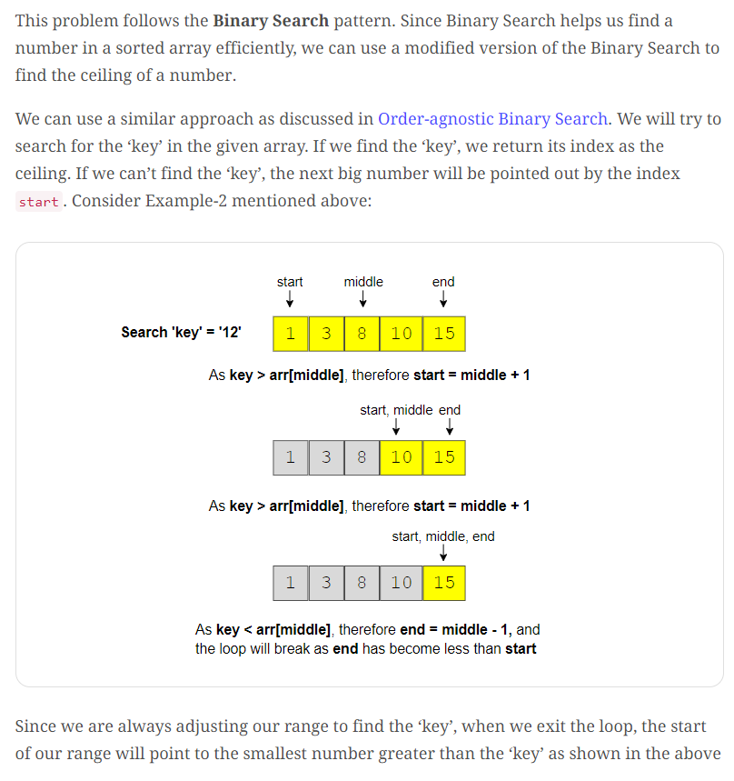

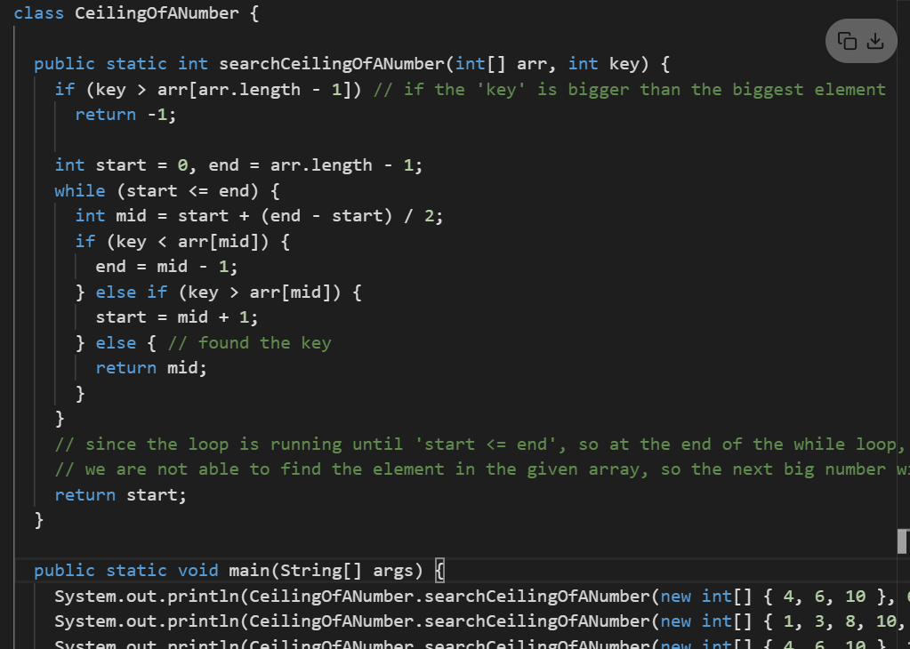

<https://www.youtube.com/watch?v=2kREIkF9UAs&feature=youtu.be>

# Articulation Points Graph Algorithm

# (two array of equal length – find median)

# 

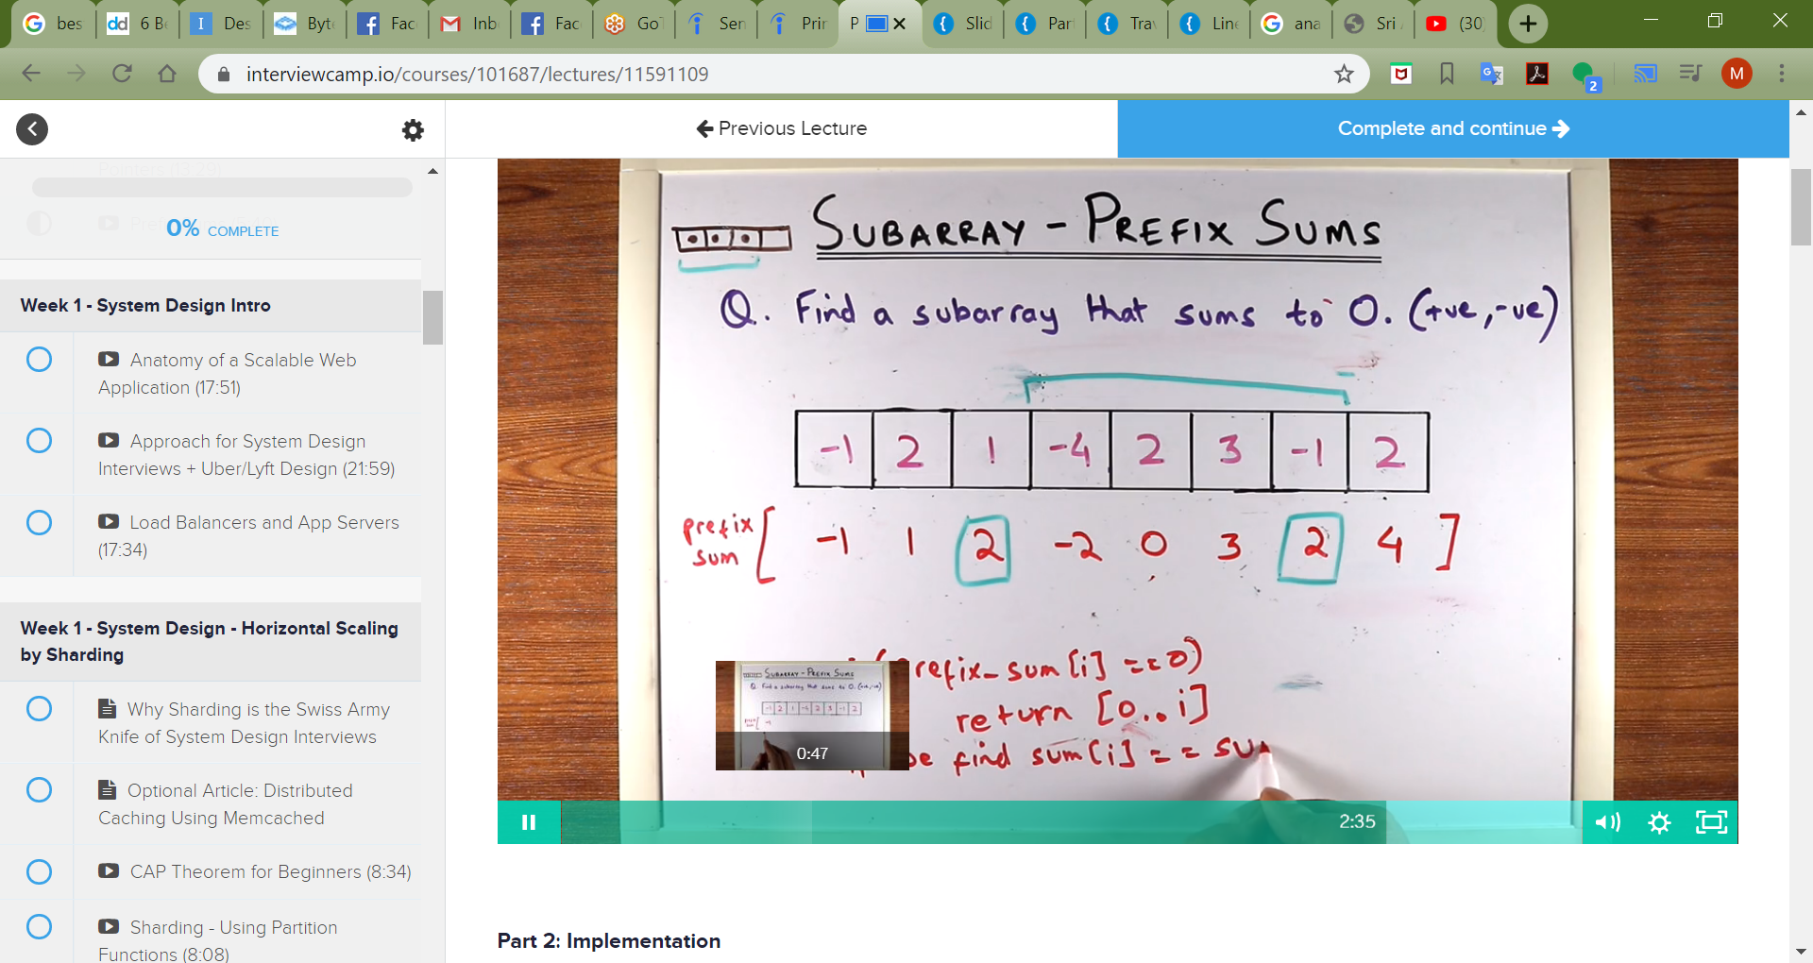

When we are solving anagram problem : simply keep the count of letters inside map and then create 2 maps for 2 strings and compare them.

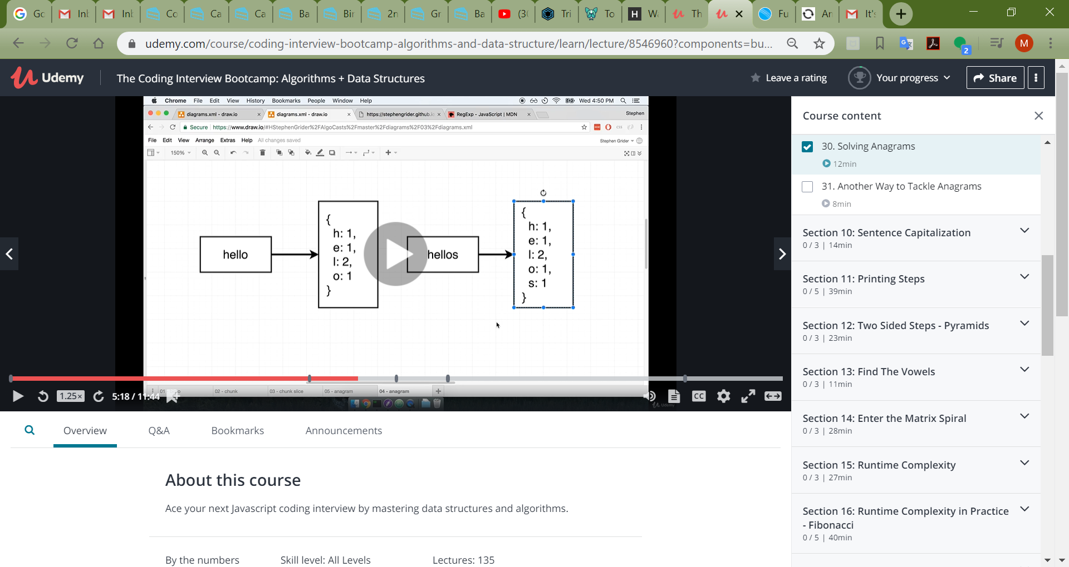

Candy Distribution :

There are *N* children standing in a line. Each child is assigned a rating value.

You are giving candies to these children subjected to the following requirements:

* Each child must have at least one candy.
* Children with a higher rating get more candies than their neighbors.

What is the minimum candies you must give?

**Example 1:**

**Input:** [1,0,2]

**Output:** 5

**Explanation:** You can allocate to the first, second and third child with 2, 1, 2 candies respectively.

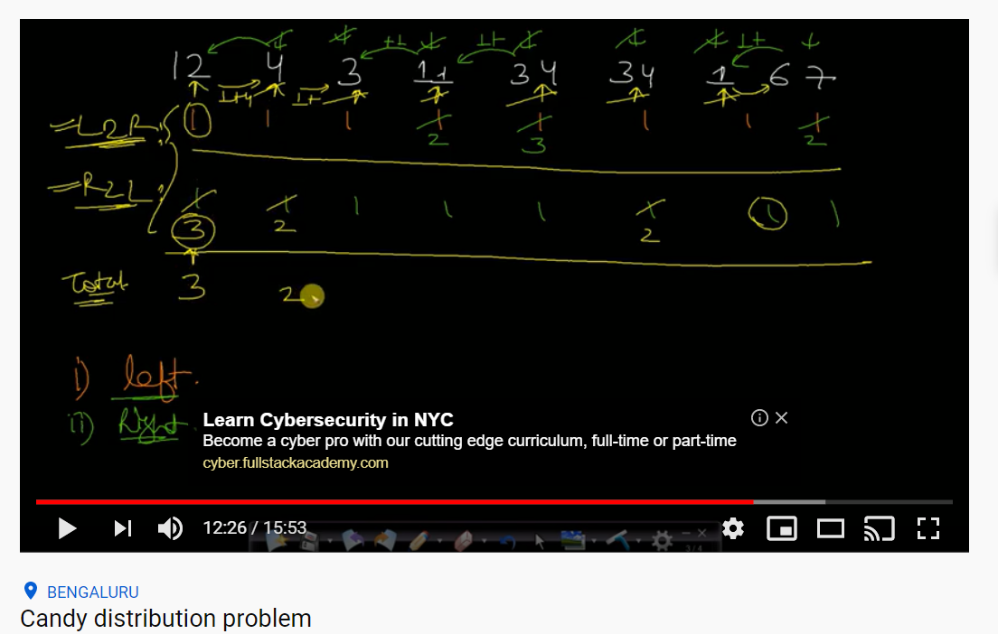

subarray.

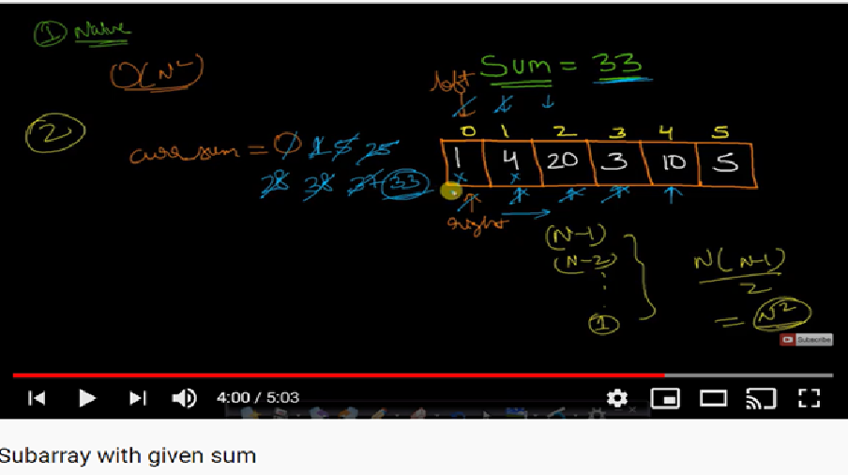

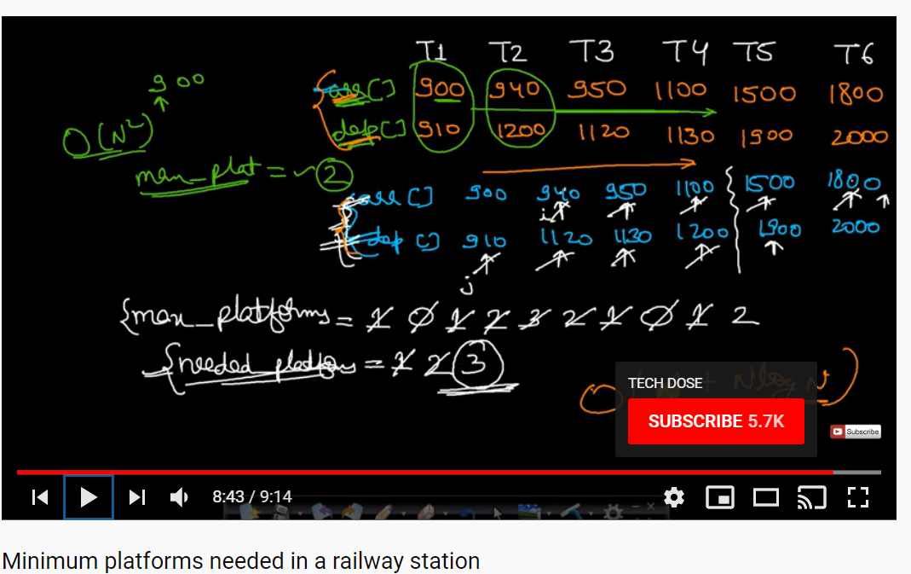

Find diameter of tree : (basically get the length of left tree and right tree and find the max total).

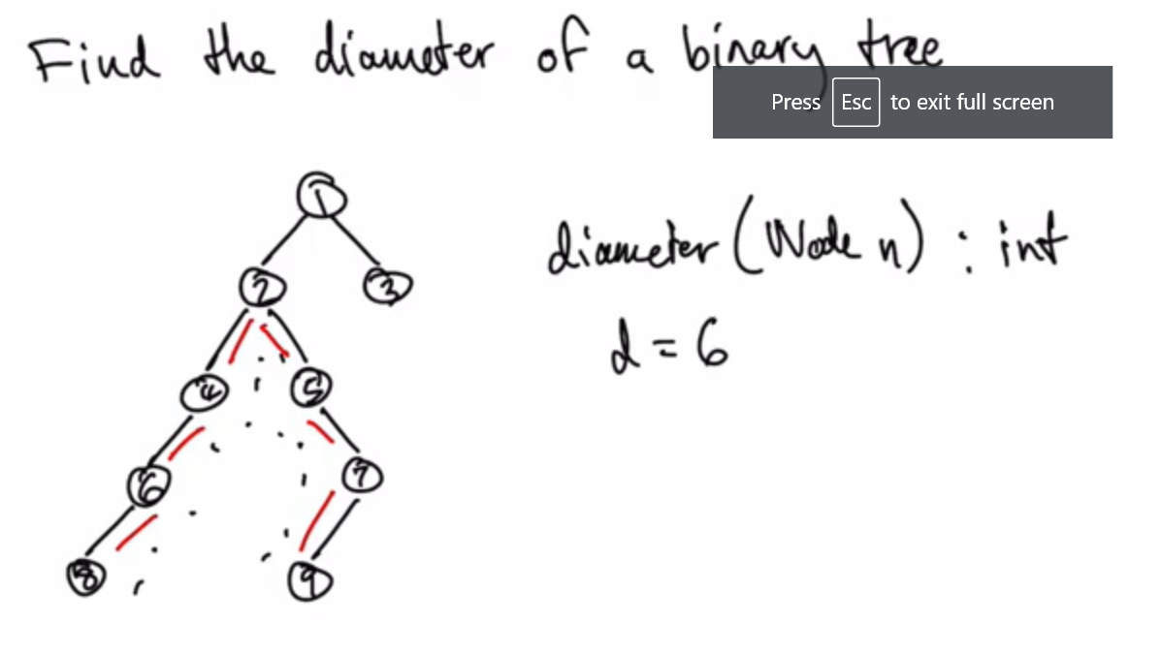

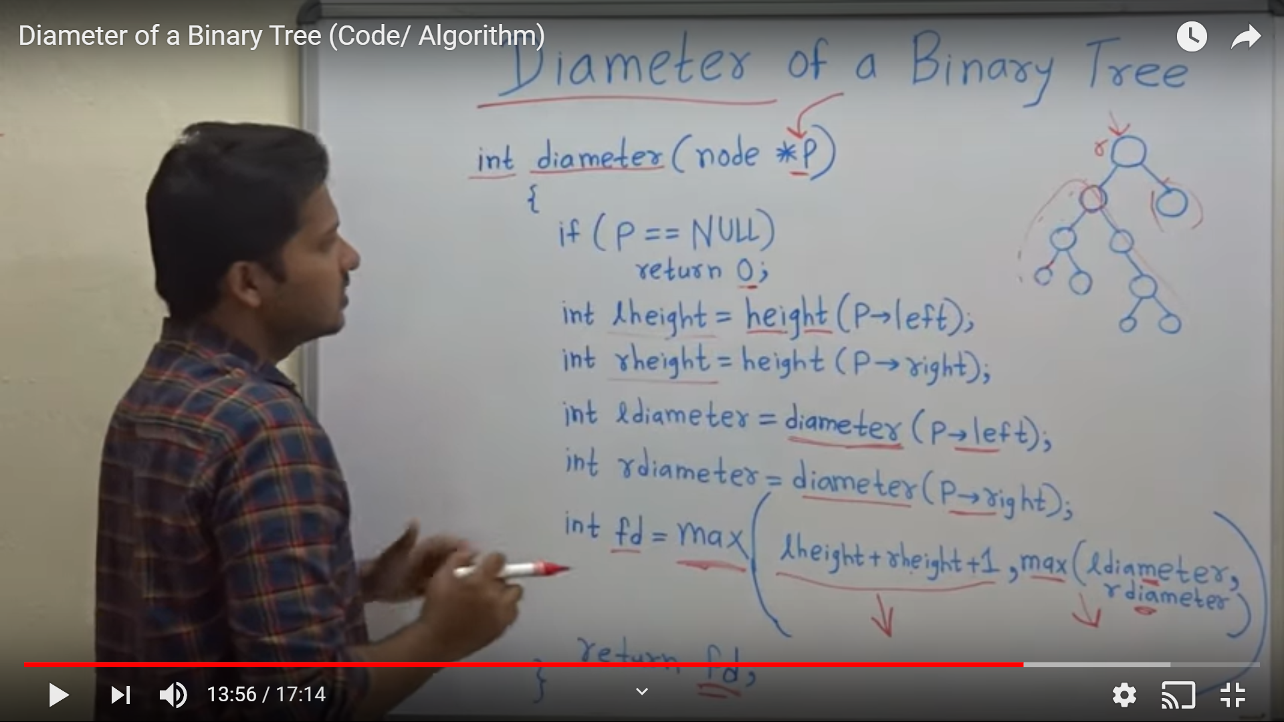

Check if the string is rotation of each other.

Basically concatenate the s1 string as s1+s1 and then search s2 in it.

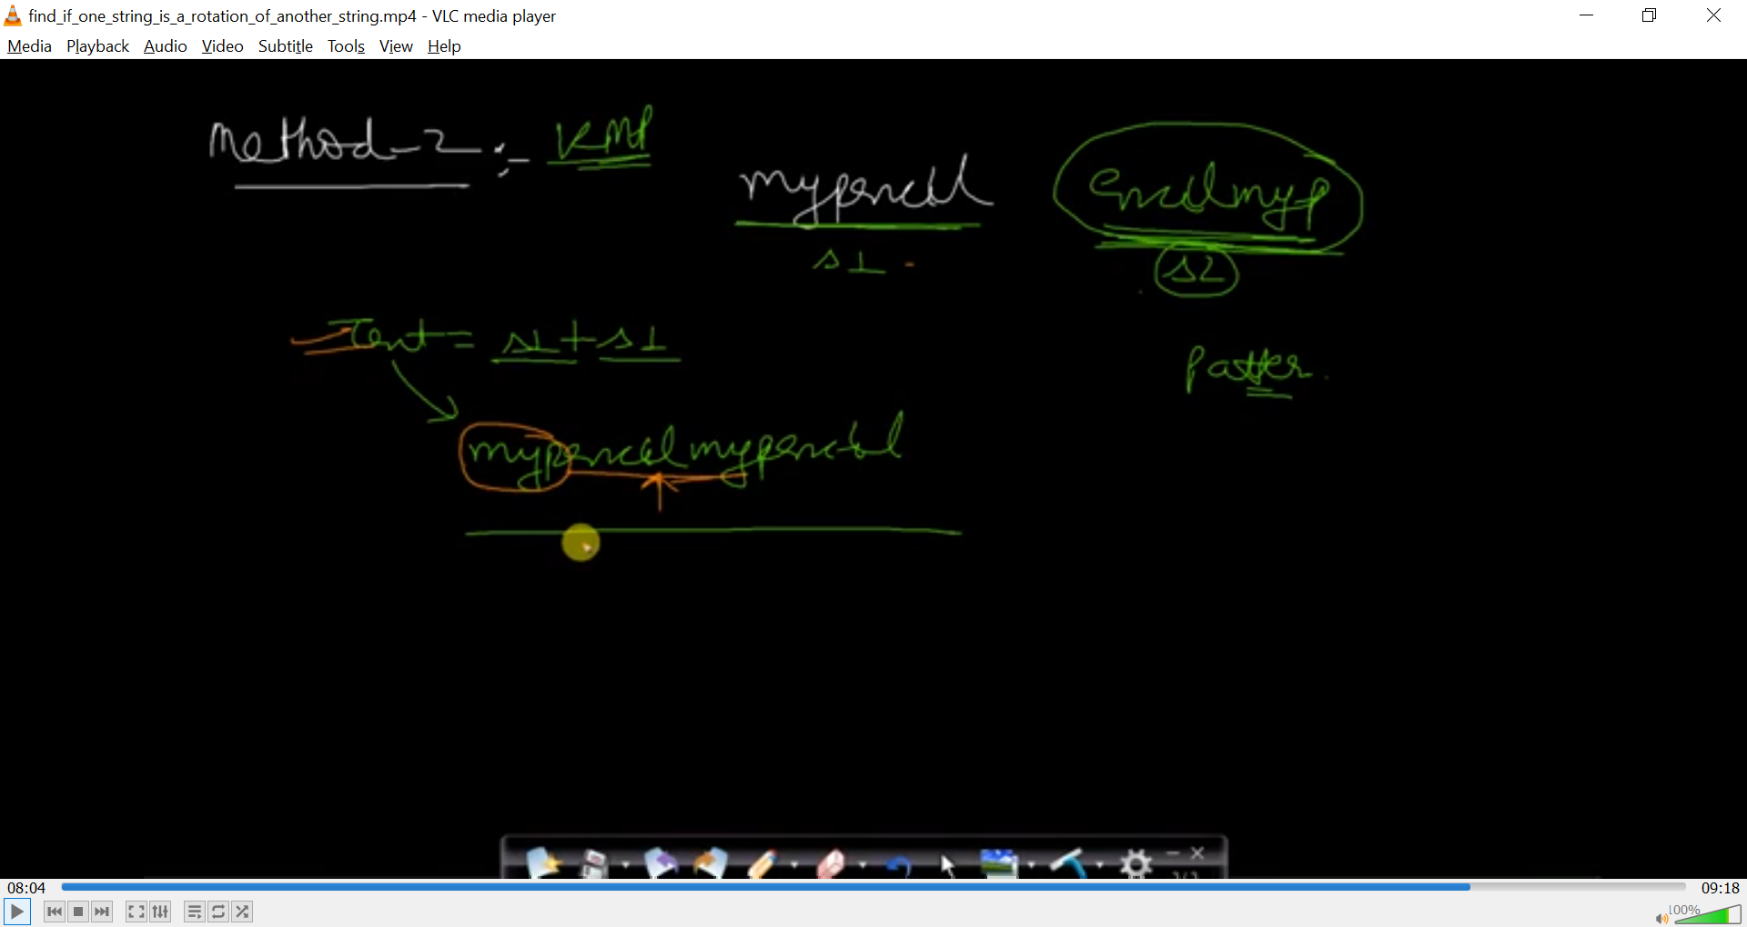

Ugly number :

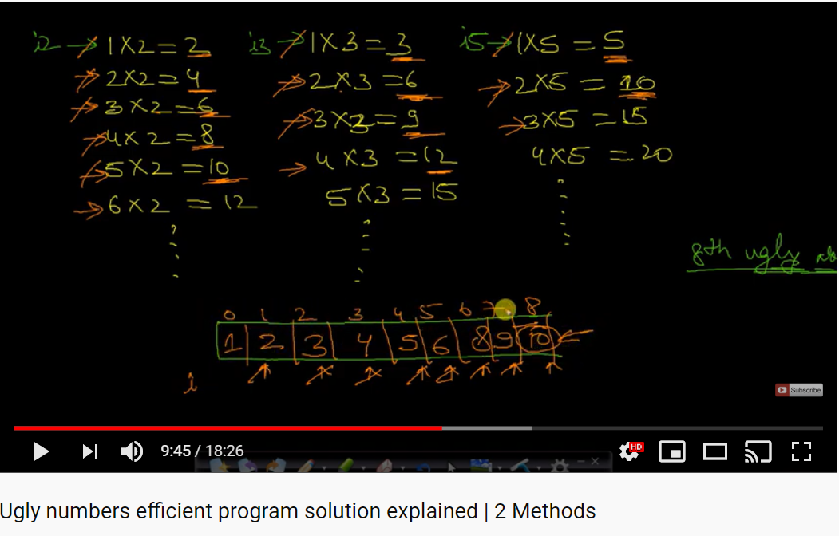

Find number of 1’s in number:

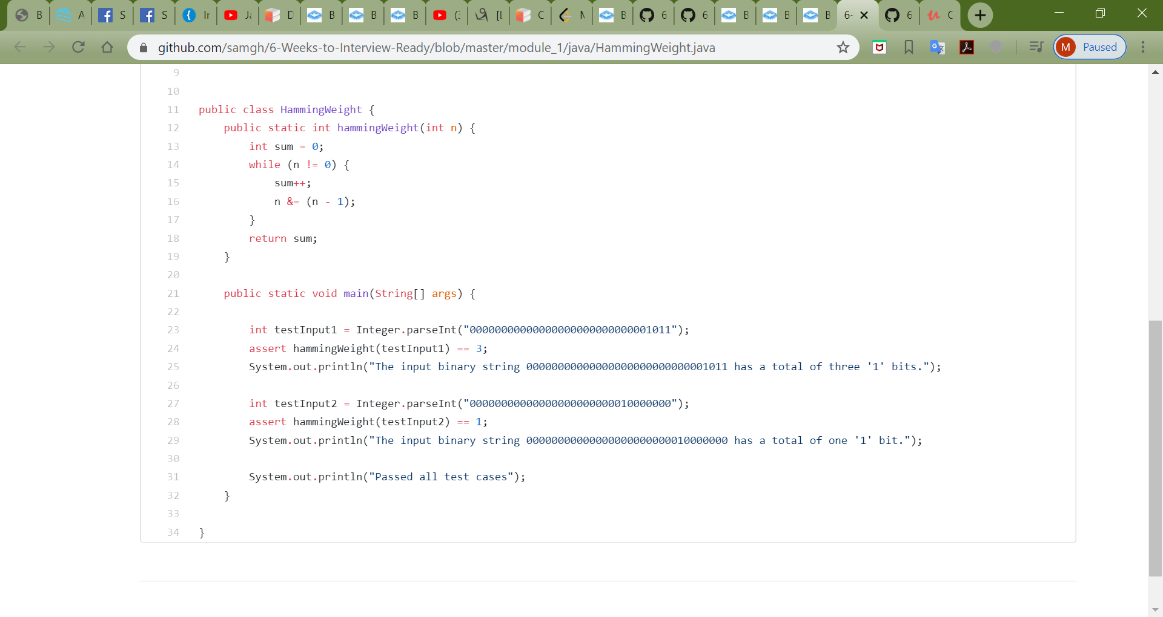

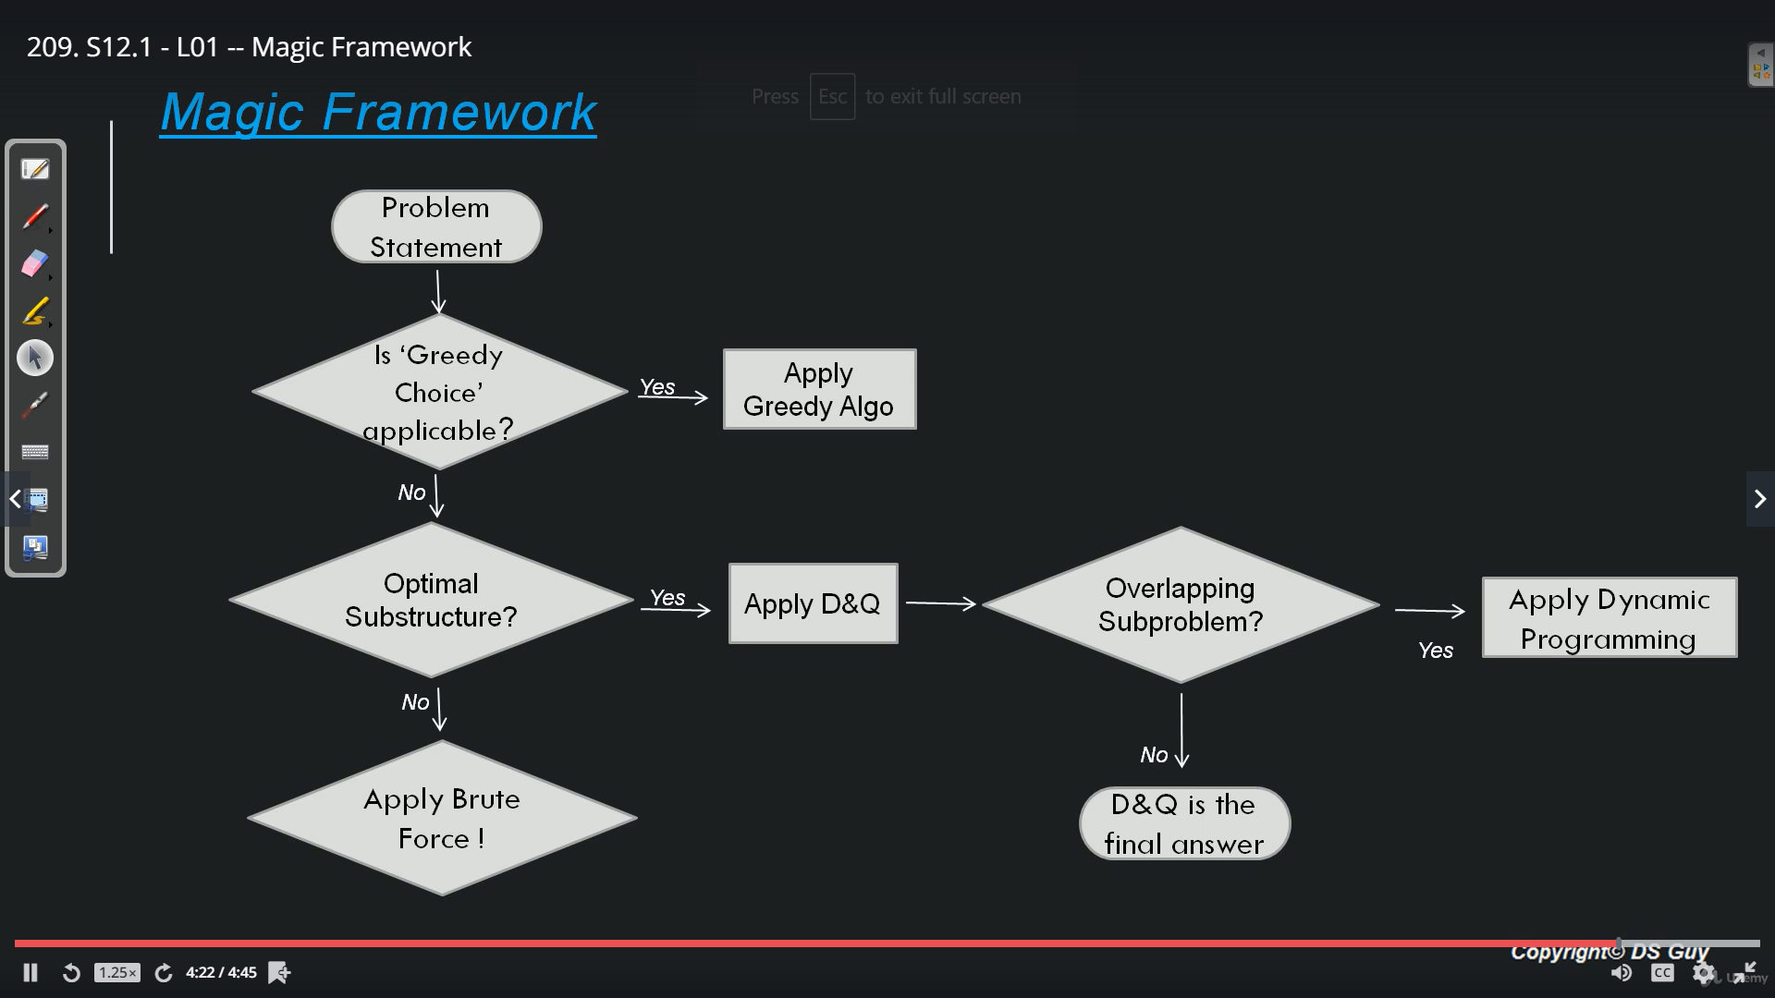

What is optimal substructure? Can we break down the bigger problem into smaller problem and then combining answers from smaller problem we solve bigger problem. But main thing here is can we break down the bigger problem into smaller problem?

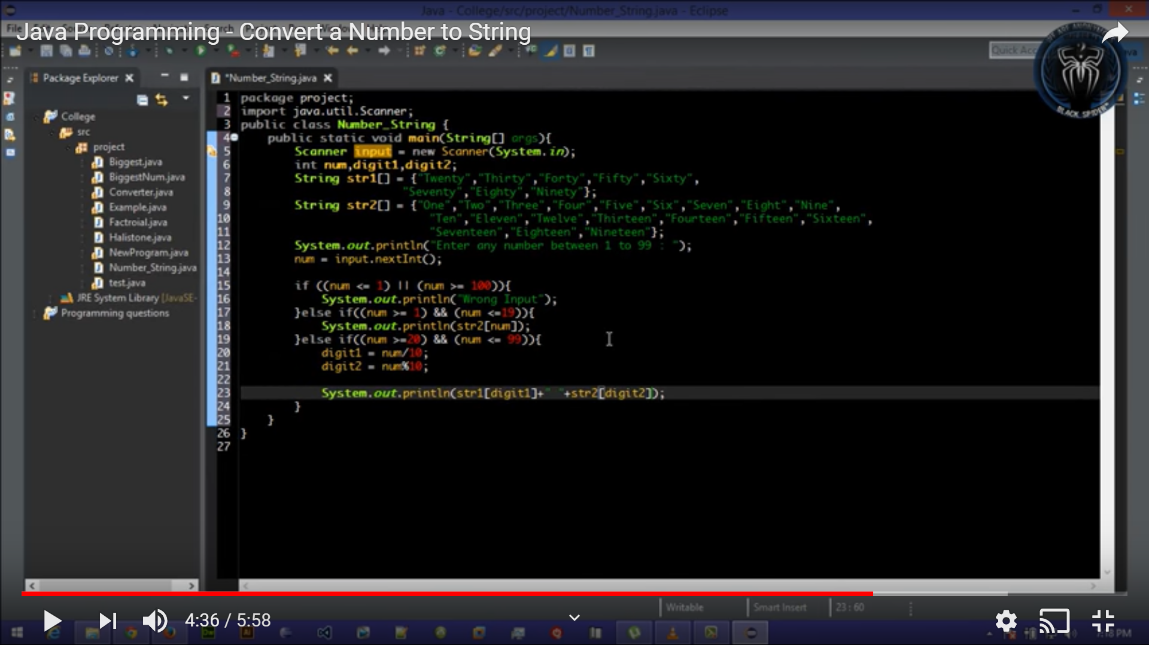

Game theory – pair (games between 2 players - strategy)

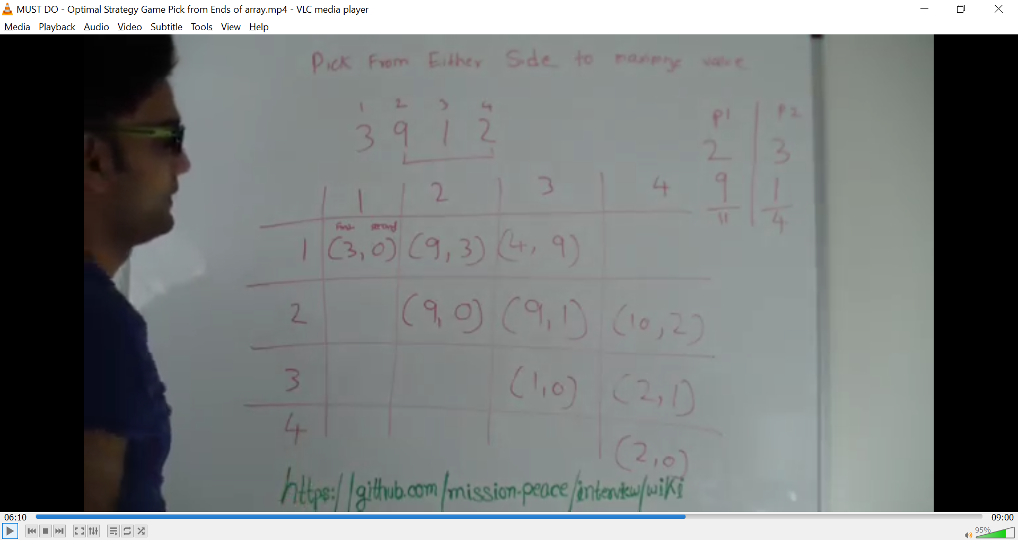

Same as Game theory – pair (games between 2 players - strategy)

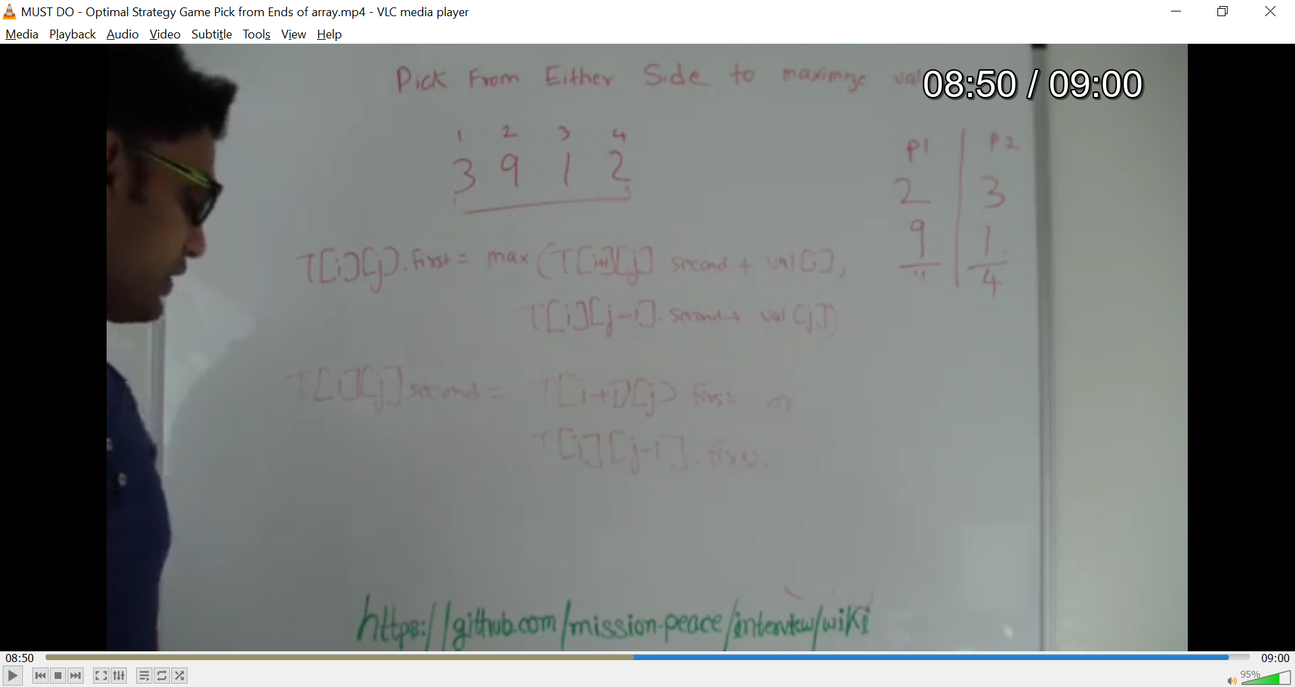

Letter combination :

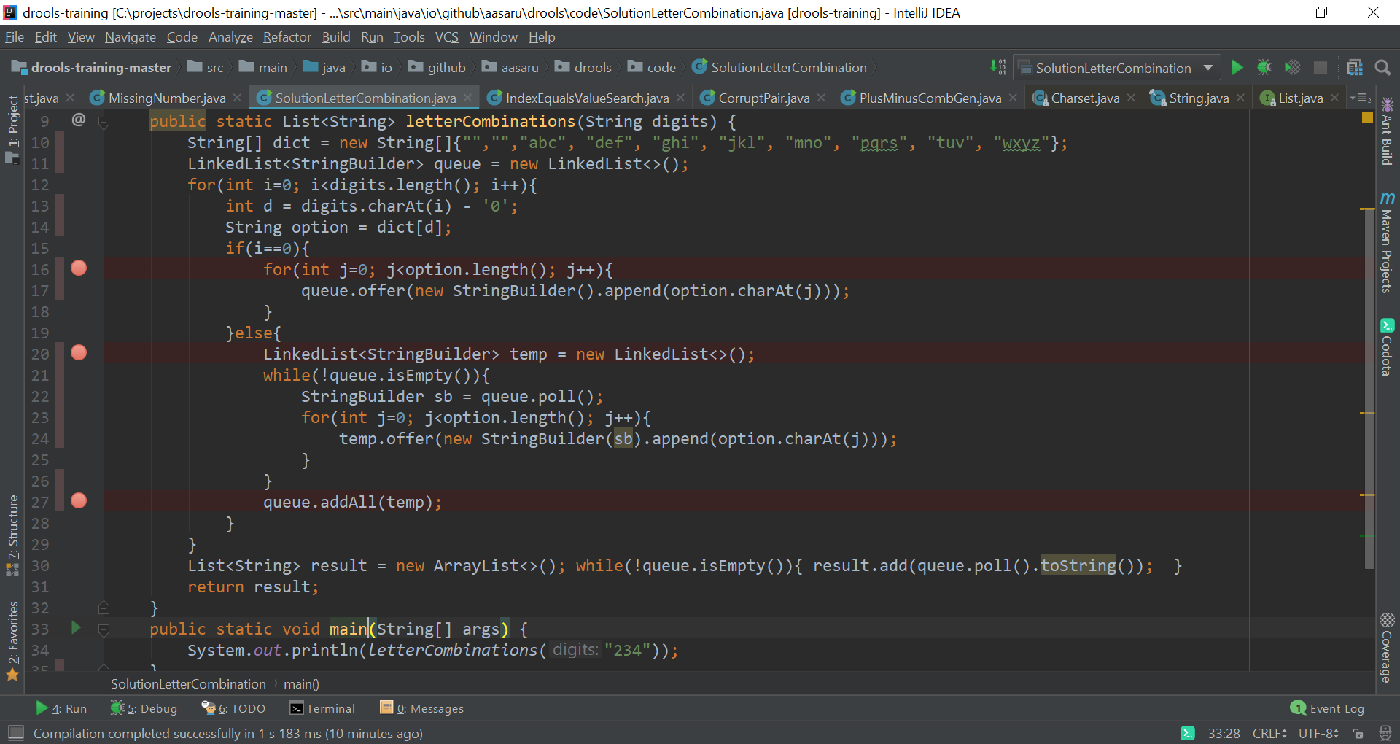

**Specials tricks. (string/array)**

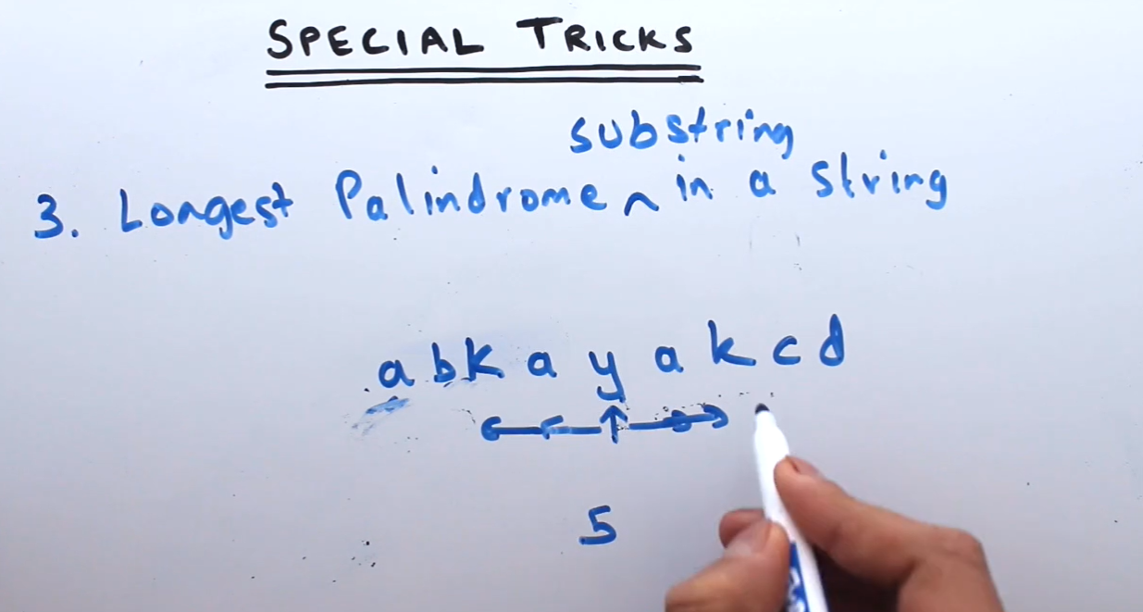

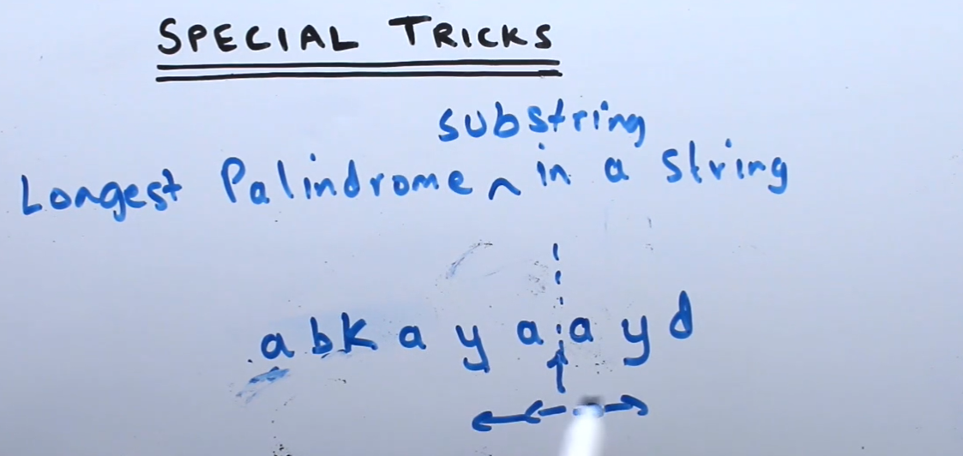

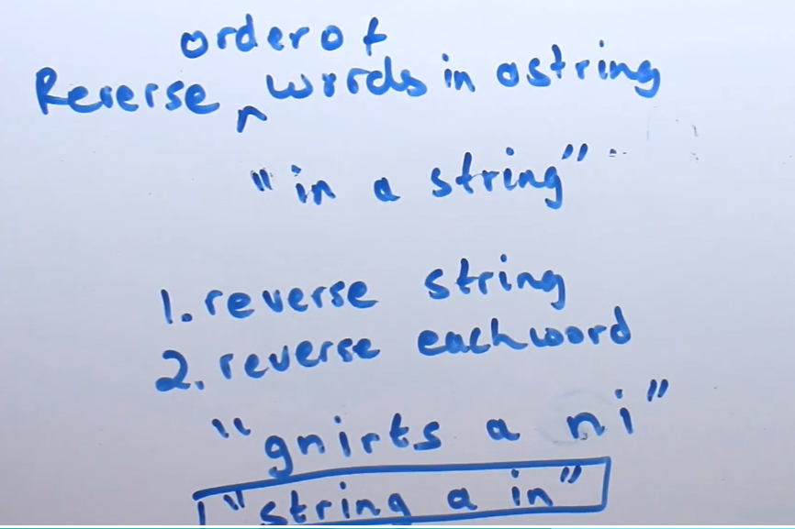

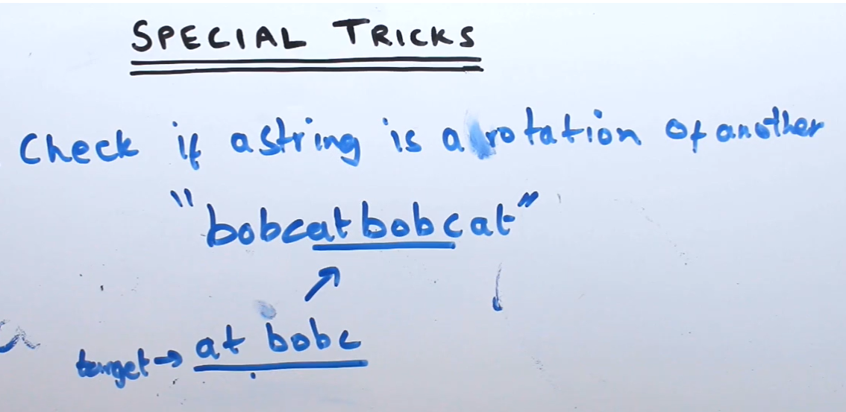

**String search.**

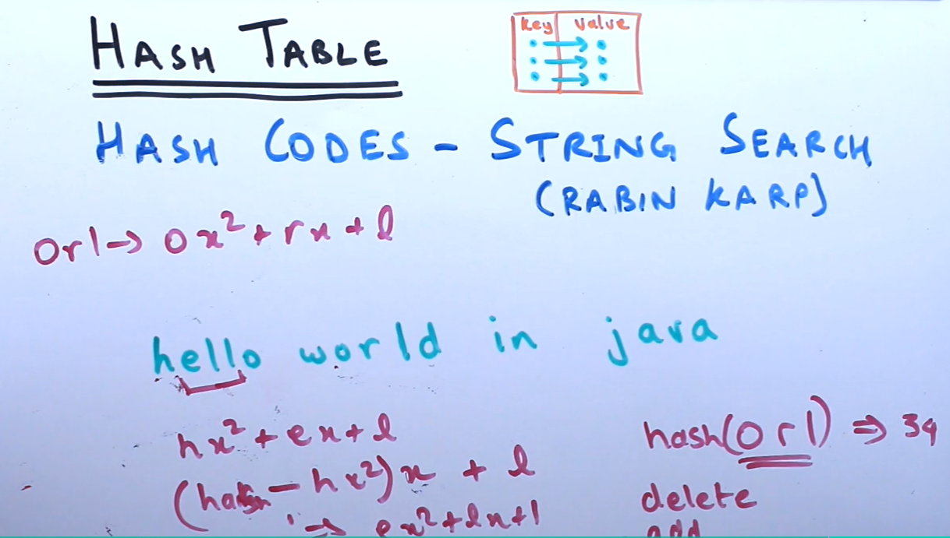

**Binary search with duplicates:**

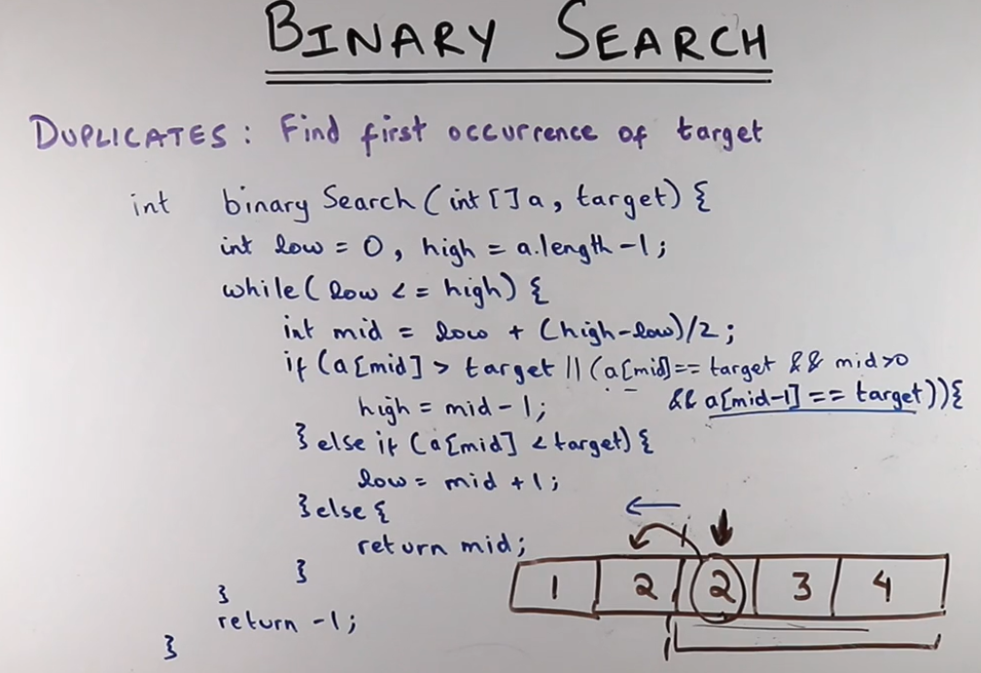

**Binary search (closest)**

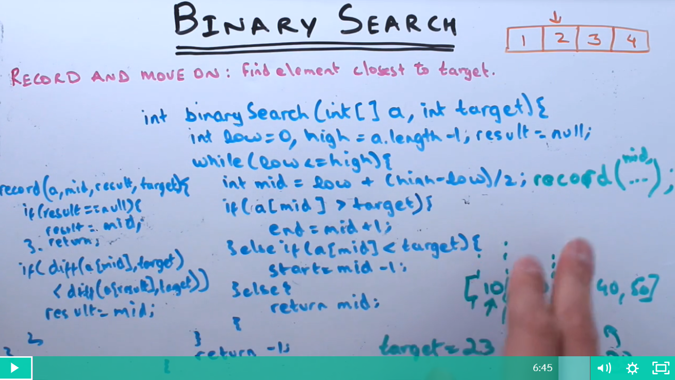

Prefix sum Is 0 – check

1. If sum of all array element is zero or balanced (below example 2 )

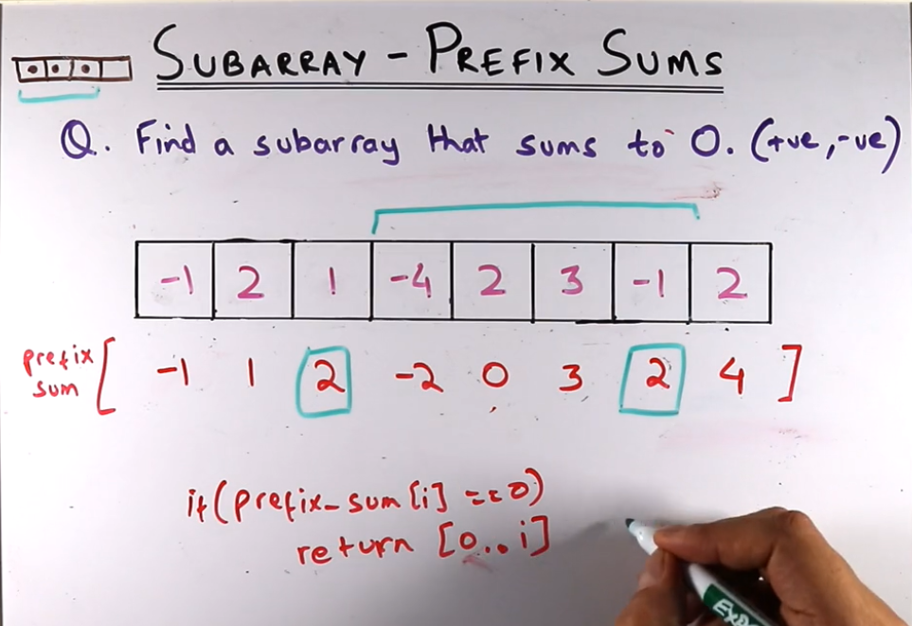

What is XOR – if we have odd numbers of 1’s then it is 1 else 0.

Letter case up/down example:

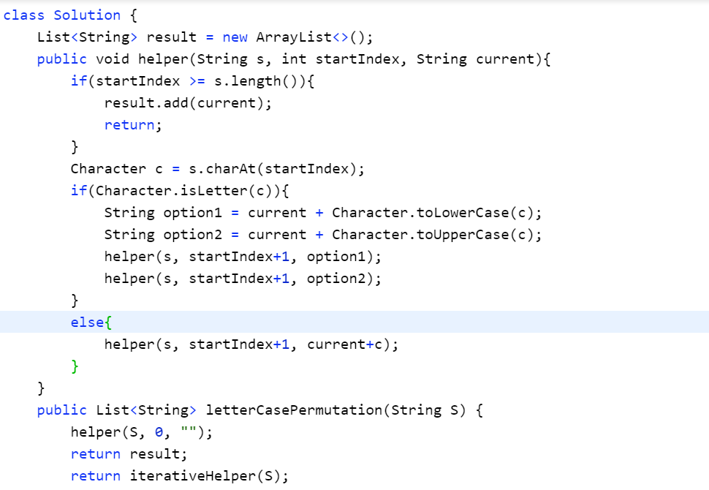

**Coloring problem! (find minimum number of colors needed for graph – udemy Algorithmic problems in java).**

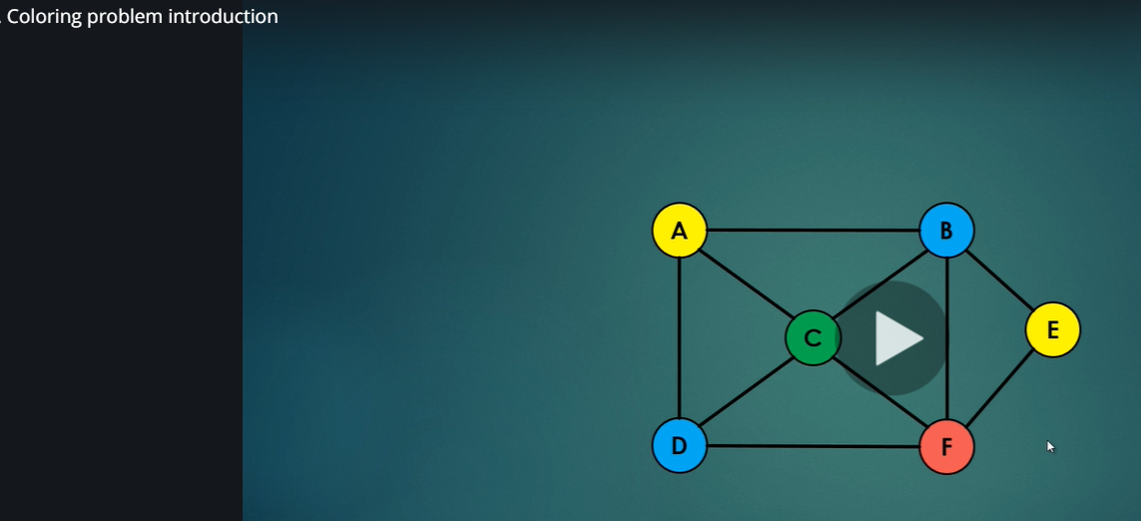

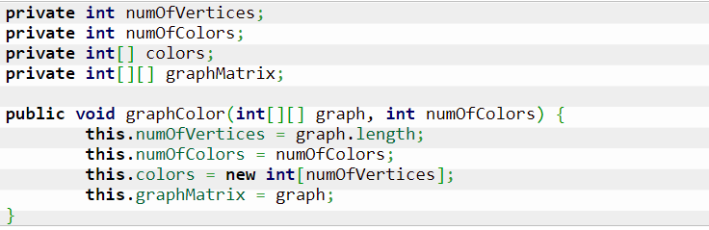

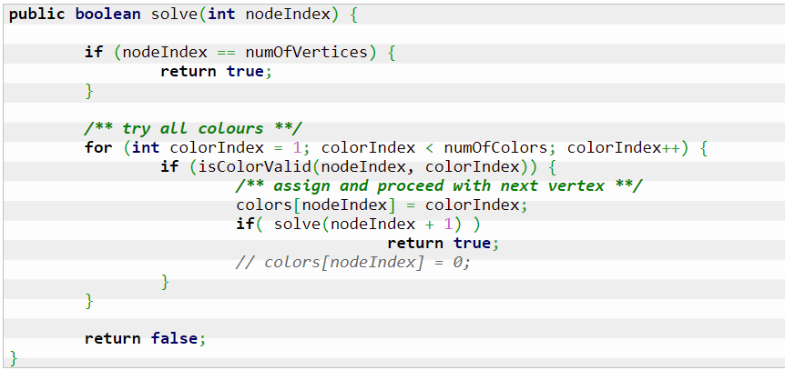

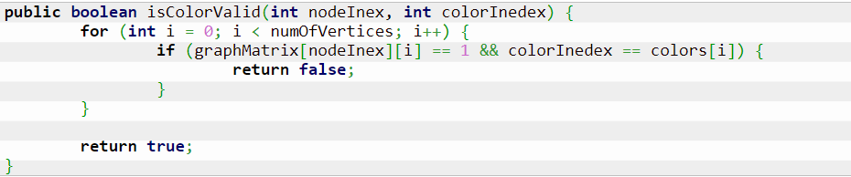

**8 queen problem:**

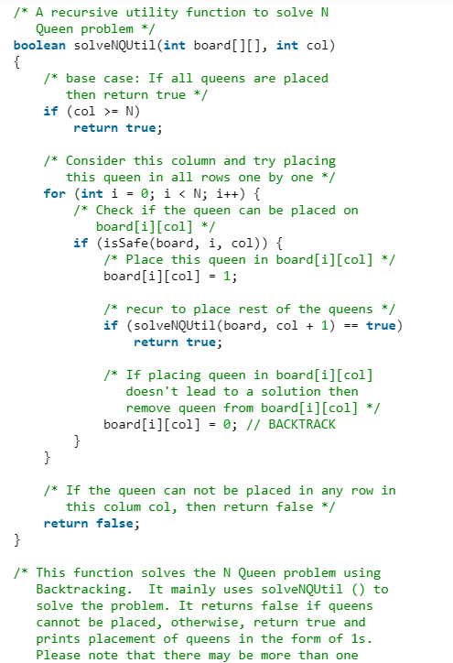

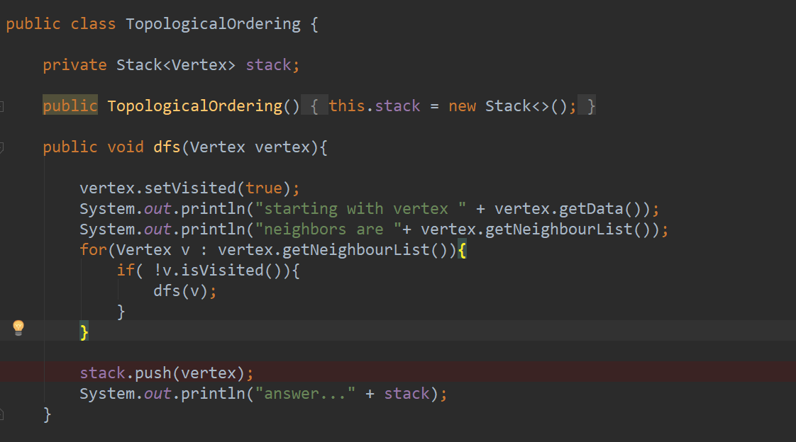

**Heap properties**

* **completeness**: we construct heaps from left to right across each row. There are no missing values (binary search trees may have missing values). Of course, the last row may not be completely full.
* **every node can have 2 children**: left child and right child
* max heap: the **parent node is always greater than the values of the children** (but the children are not necessarily ordered). It means the root node is the item with maximum value.

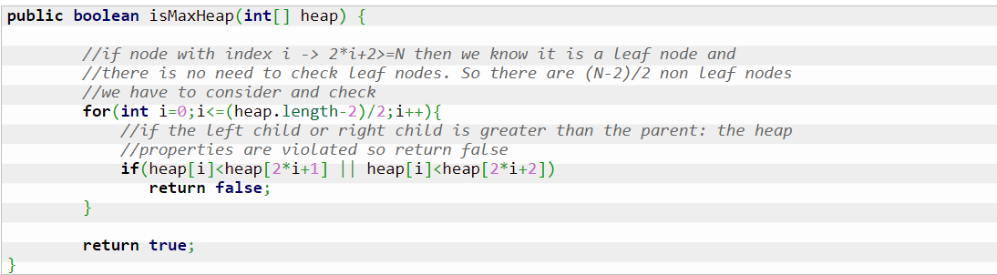

Binary search tree delete :

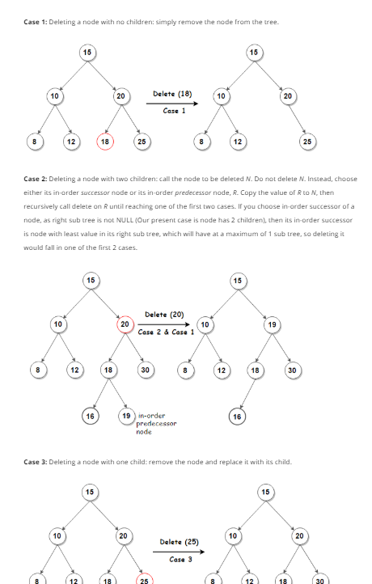

// Data structure to store a Binary Search Tree node  
class Node  
{  
 int data;  
 Node left = null, right = null;  
  
 Node(int data) {  
 this.data = data;  
 }  
}  
  
class Main  
{  
 // Function to perform inorder traversal of the BST  
 public static void inorder(Node root)  
 {  
 if (root == null)  
 return;  
  
 inorder(root.left);  
 System.out.print(root.data + " ");  
 inorder(root.right);  
 }  
  
 // Helper function to find minimum value node in subtree rooted at curr  
 public static Node minimumKey(Node curr)  
 {  
 while(curr.left != null) {  
 curr = curr.left;  
 }  
 return curr;  
 }  
  
 // Recursive function to insert an key into BST  
 public static Node insert(Node root, int key)  
 {  
 // if the root is null, create a new node an return it  
 if (root == null) {  
 return new Node(key);  
 }  
  
 // if given key is less than the root node, recur for left subtree  
 if (key < root.data) {  
 root.left = insert(root.left, key);  
 }  
  
 // if given key is more than the root node, recur for right subtree  
 else {  
 root.right = insert(root.right, key);  
 }  
  
 return root;  
 }  
  
 // Function to delete node from a BST  
 public static Node deleteNode(Node root, int key)  
 {  
 // pointer to store parent node of current node  
 Node parent = null;  
  
 // start with root node  
 Node curr = root;  
  
 // search key in BST and set its parent pointer  
 while (curr != null && curr.data != key)  
 {  
 // update parent node as current node  
 parent = curr;  
  
 // if given key is less than the current node, go to left subtree  
 // else go to right subtree  
 if (key < curr.data) {  
 curr = curr.left;  
 }  
 else {  
 curr = curr.right;  
 }  
 }  
  
 // return if key is not found in the tree  
 if (curr == null) {  
 return root;  
 }  
  
 // Case 1: node to be deleted has no children i.e. it is a leaf node  
 if (curr.left == null && curr.right == null)  
 {  
 // if node to be deleted is not a root node, then set its  
 // parent left/right child to null  
 if (curr != root) {  
 if (parent.left == curr) {  
 parent.left = null;  
 } else {  
 parent.right = null;  
 }  
 }  
 // if tree has only root node, delete it and set root to null  
 else {  
 root = null;  
 }  
 }  
  
 // Case 2: node to be deleted has two children  
 else if (curr.left != null && curr.right != null)  
 {  
 // find its in-order successor node  
 Node successor = minimumKey(curr.right);  
  
 // store successor value  
 int val = successor.data;  
  
 // recursively delete the successor. Note that the successor  
 // will have at-most one child (right child)  
 deleteNode(root, successor.data);  
  
 // Copy the value of successor to current node  
 curr.data = val;  
 }  
  
 // Case 3: node to be deleted has only one child  
 else  
 {  
 // find child node  
 Node child = (curr.left != null)? curr.left: curr.right;  
  
 // if node to be deleted is not a root node, then set its parent  
 // to its child  
 if (curr != root)  
 {  
 if (curr == parent.left) {  
 parent.left = child;  
 } else {  
 parent.right = child;  
 }  
 }  
  
 // if node to be deleted is root node, then set the root to child  
 else {  
 root = child;  
 }  
 }  
  
 return root;  
 }  
  
 // main function  
 public static void main(String[] args)  
 {  
 Node root = null;  
 int[] keys = { 15, 10, 20, 8, 12, 16 };  
  
 for (int key : keys) {  
 root = insert(root, key);  
 }  
  
 root = deleteNode(root, 16);  
 inorder(root);  
 }  
}

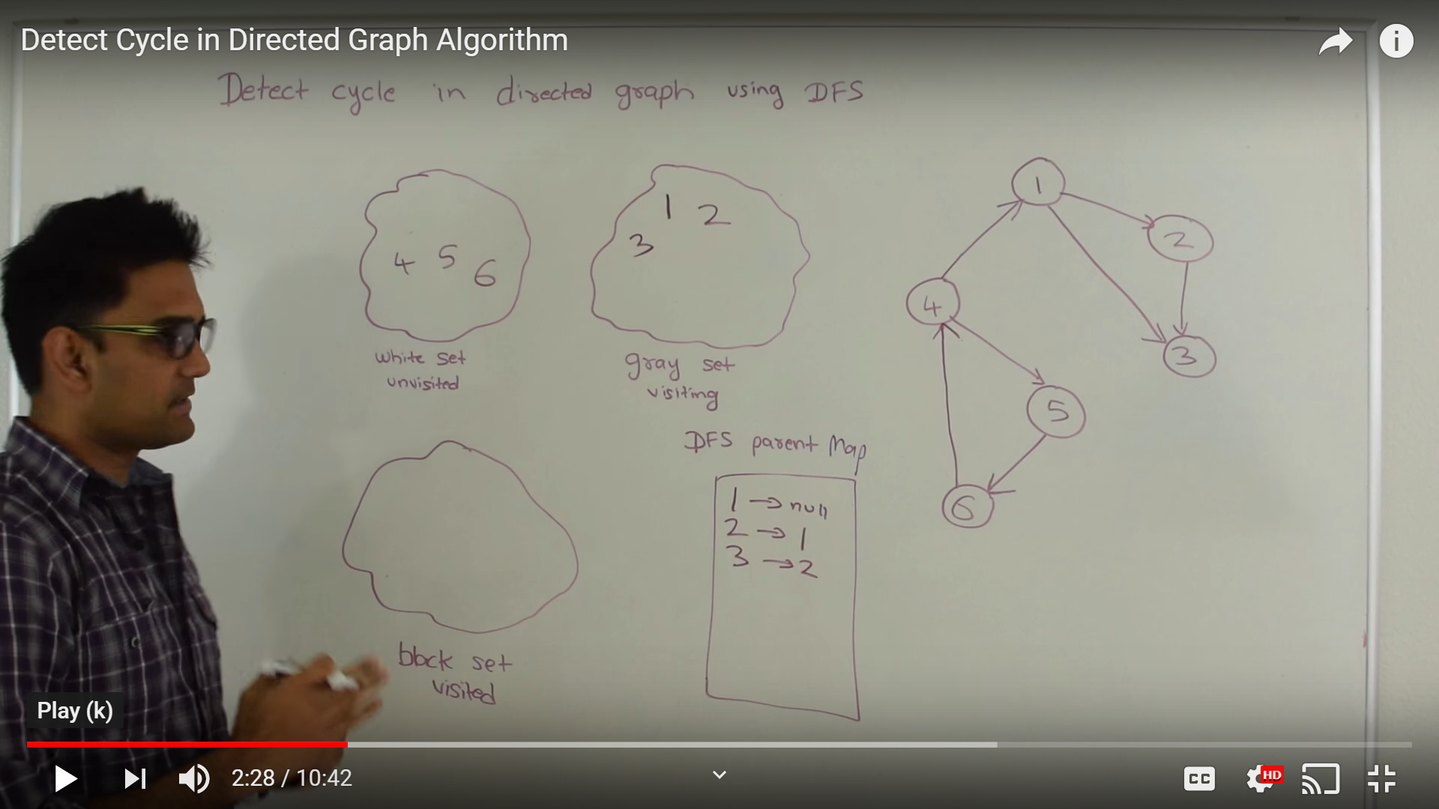

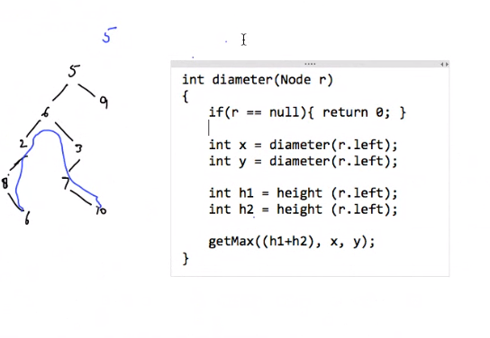

Ritambhara DP – problems. (we have book and kindle book)

